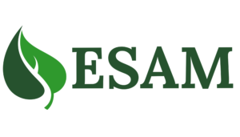

Environmental Services Association Maritimes
Scholarship Program

Purpose:

To Provide a $500 scholarship to three deserving high school graduates intending to pursue a post-secondary education in a science or environmental program. Three scholarships will be awarded, one in each Maritime province.

Criteria:
- Applicant must be a resident of the Maritimes.

- Applicant must be a graduating high school senior and be accepted to attend a post-secondary institution in the year of award.

- Applicant must be furthering their education in a science or environmental field of study.

Required with your application:

- Completed Application Form

- Proof of Acceptance to a Post-Secondary Institution

- Letter of recommendation from a teacher or community member

- A 250-500 word essay explaining why you have chosen to pursue an education in the science/environmental field.
- Files must be submitted as Word or PDF files (links to Google Docs cannot always be viewed)

Please email your submission to: contact@esamaritimes.ca.

Deadline for the receipt of applications is June 1, 2024
Scholarship Application

1. | Last Name: | First Name:
2. | Mailing Address: Street: _________________________________________________________  City: _____________________ Province: ________ Postal Code: ____________
3. | Daytime Telephone Number: ( ) Email Address:
4. | Current High School:
5. | Name of the school you will be attending in the fall: ____________________________________________  What field do you plan to major in as you continue your education? ________________________________
6. | List your academic honors, awards and membership activities while in high school  ______________________________________________________________________________________  ______________________________________________________________________________________  ______________________________________________________________________________________  ______________________________________________________________________________________  ______________________________________________________________________________________

STATEMENT OF ACCURACY

I hereby affirm that all the above stated information provided by me is true and correct to the best of my knowledge.

Signature of scholarship applicant: _______________________________ Date: _____________

